LAB ASSIGNMENT 9 (UG/02/BTCSEAIML/2023/065)

WACP to implement FCFS (with AT i.e activation time).

Answer:
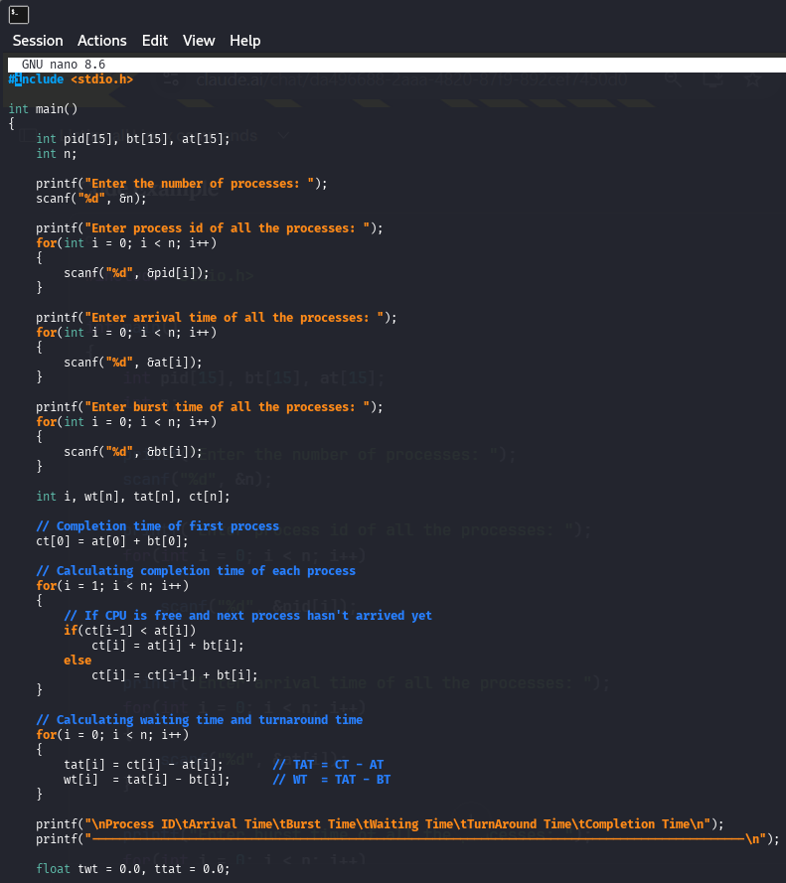
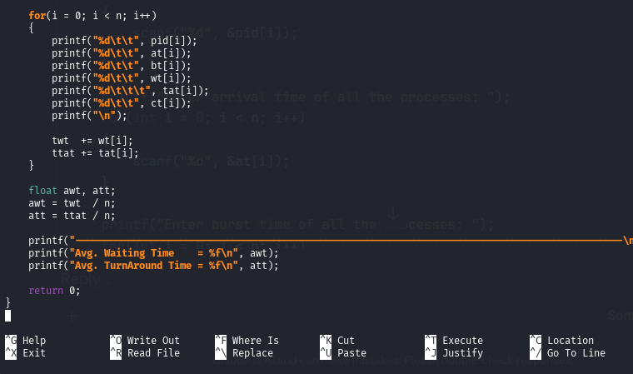

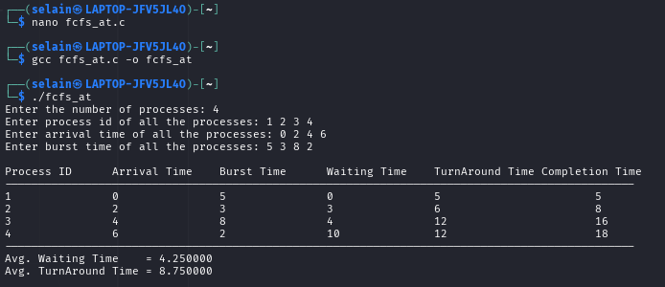
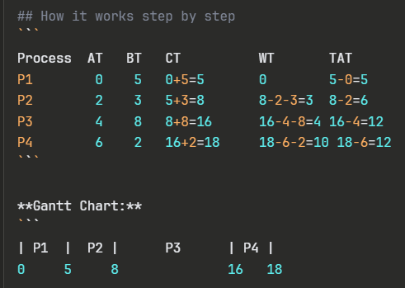
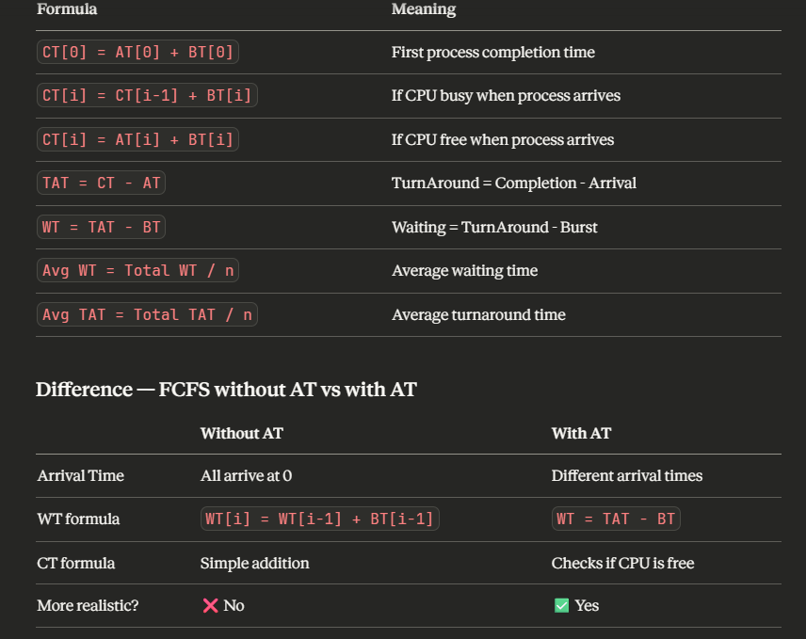
The key idea is that with Arrival Time, we must check if the CPU is free or busy when the next process arrives — if the CPU finishes before the next process arrives, it stays idle until that process arrives!

